Title: Online Flight Reservation System
Aim
To develop a web-based Flight Reservation System that allows users to search flights, book tickets, check booking status, make payments, cancel tickets, and print e-tickets.
Algorithm
- Start the application.
- Allow users to log in and search flights.
- Display available flights, dates, classes, and fares.
- Enter passenger details and book tickets.
- Process payment and display booking confirmation.
- Allow users to view, print, or cancel tickets.
- Allow admins to manage flights and generate reports.
- Stop the application.
HTML Code

<!DOCTYPE html>
<html lang="en">
<head>
<meta charset="UTF-8">
<meta name="viewport" content="width=device-width, initial-scale=1.0">
<title>Flight Reservation System</title>
<style>
body { font-family: Arial; background: #eef3f8; margin: 0; }
header { background: #163d69; color: white; text-align: center; padding: 20px; }
main { max-width: 550px; margin: 25px auto; background: white; padding: 20px; }
input, select, button { width: 100%; padding: 10px; margin: 8px 0; box-sizing: border-box; }
button { background: #087e8b; color: white; border: none; cursor: pointer; }
footer { text-align: center; padding: 15px; }
</style>
</head>
<body>

<header>
<h1>Flight Reservation System</h1>
<p>Book Your Flight Easily</p>
</header>

<main>
<h2>Search Flights</h2>

<form id="flightForm">
<label for="from">From:</label>
<input id="from" required placeholder="Departure city">

<label for="to">To:</label>
<input id="to" required placeholder="Destination city">

<label for="date">Travel Date:</label>
<input id="date" type="date" required>

<label for="classType">Travel Class:</label>
<select id="classType">
<option>Economy</option>
<option>Business</option>
<option>First Class</option>
</select>

<button type="submit">Search Flights</button>
</form>

<div id="result"></div>

<h2>My Ticket</h2>
<input id="ticket" placeholder="Enter booking ID">
<button onclick="viewTicket()">View Booking Status</button>
<button onclick="cancelTicket()">Cancel Ticket</button>
<p id="message"></p>

<h2>Customer Feedback</h2>
<input id="feedback" placeholder="Enter your feedback">
<button onclick="submitFeedback()">Submit Feedback</button>
<p id="feedbackMessage"></p>
</main>

<footer>
<p>&copy; 2026 Flight Reservation System</p>
</footer>

<script>
document.getElementById("flightForm").onsubmit = function(e) {
e.preventDefault();

let from = document.getElementById("from").value.trim();
let to = document.getElementById("to").value.trim();
let date = document.getElementById("date").value;
let cls = document.getElementById("classType").value;

if (from.toLowerCase() === to.toLowerCase()) {
document.getElementById("result").textContent =
"Departure and destination must be different.";
return;
}

document.getElementById("result").innerHTML =
"<h3>Sample Flight</h3>" +
"<p>Route: " + from + " to " + to + "</p>" +
"<p>Date: " + date + "</p>" +
"<p>Class: " + cls + "</p>" +
"<p>Available Seats: 20 (Demo)</p>" +
"<p>Fare: ₹4000 (Demo)</p>" +
"<button onclick='alert(\"Demo only: no ticket booked.\")'>Book Flight</button>";
};

function viewTicket() {
let id = document.getElementById("ticket").value.trim();
document.getElementById("message").textContent =
id ? "Demo only: booking status is not connected to a database."
: "Please enter a booking ID.";
}

function cancelTicket() {
let id = document.getElementById("ticket").value.trim();
document.getElementById("message").textContent =
id ? "Demo only: ticket cancellation requires a booking system."
: "Please enter a booking ID.";
}

function submitFeedback() {
let feedback = document.getElementById("feedback").value.trim();
document.getElementById("feedbackMessage").textContent =
feedback ? "Thank you for your feedback!"
: "Please enter your feedback.";
}
</script>

</body>
</html>
Output:
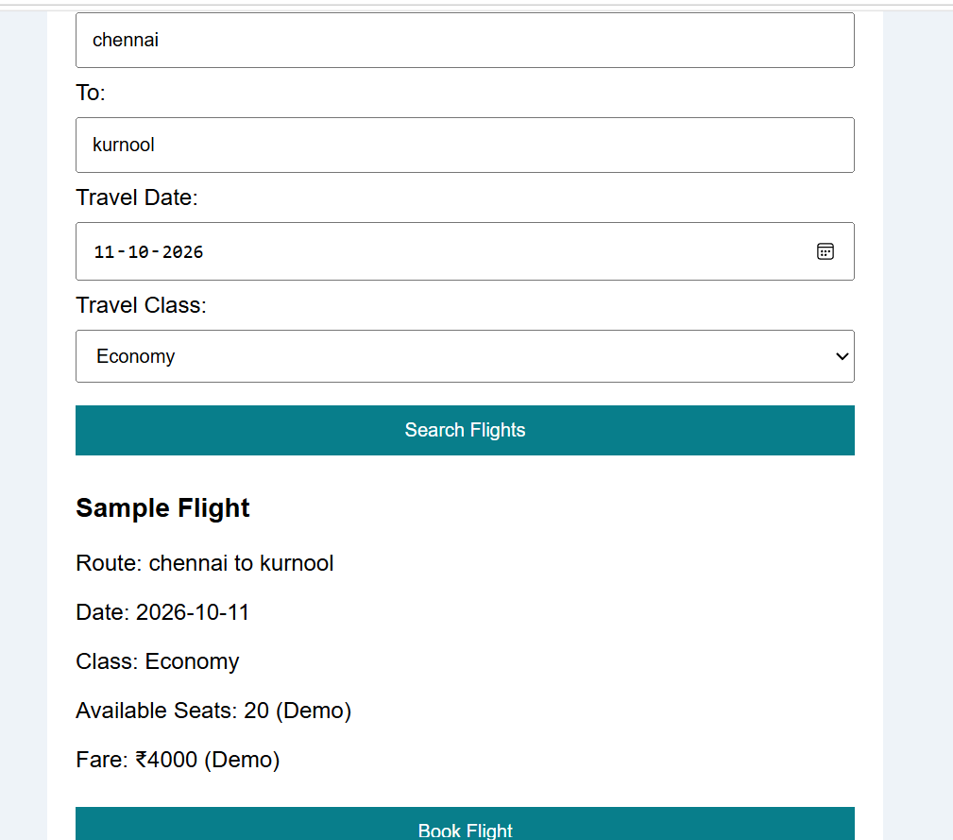
Result
The Flight Reservation System webpage was created successfully. Users can search sample flights, select travel classes, view demo booking status, cancel a demo ticket, and submit feedback.

